Research Title
(Single column format, Single line space, Time new roman, Font size 18, Centralized, Title case)
First Author^{1*}, Second Author², Third Author³
(Single column format, Single line space, Time new roman, Font size 11, Centralized, Title case)
¹Designation, Department/Faculty, University, City, Country, ORCID ID
²Designation, Department/Faculty, University, City, Country, ORCID ID
³Designation, Department/Faculty, University, City, Country, ORCID ID
(Single column format, Single line space, Time new roman, Font size 10, Centralized, Title case)
Emails: email1@authorname.com*, email2@authorname.com, email3@authorname.com

*Corresponding Author

Received: 00-00-2023; Accepted: 00-00-2023; Published: 00-00-2023
DOI: 10.5281/zenodo.0000000

ABSTRACT
An abstract is a short summary of your research paper, usually about a paragraph (150-300 words) long. A well-written abstract can let readers get the essence of your paper, prepare readers to follow the detailed information, analyses, and arguments in your full paper, and help readers remember the key points. Note: -Special symbols, mathematical formulas, and equations are not allowed in the "Abstract" section. References should not be cited in the abstract.
(Single column format, Single line space, Time new roman, Font size 11, Justified)
Keywords: We would like to encourage you to list your keywords here. They should be separated by commas. Keywords (except the first one) start with small letters and the last one ends with a dot. The authors must provide up to 6-8 keywords for indexing purposes (vital words of the article).

Cite as: First Author, Second Author (Year). Type the Research Title. LC International Journal of STEM, 4(1), 68–85. https://doi.org/10.1037/edu0000696

1. INTRODUCTION
(Single column format, Single line space, Time new roman, Font size 12, Bold, Upper Case, Left align)

Put your introduction here. Begin by identifying the research problems & issues giving a brief background (cover the brief summaries of at least 5-10 relevant research articles and their critical appraisal, literature should include 70 % literature from last 10 years out of which 50% from last 5 years. Researcher can use old reference in exceptional cases e.g. giving definitions, details of tools etc.), reason for conduction of this study by identify the research gap, significance and rationale of the study, also put the major goal of the study, specific objectives/questions and hypothesis here. Hypothesis should be written like this, Ho1, Ho2, Ho3 etc. Introduction should be 1000-1500 words.

All manuscripts must contain an Introduction, typically 3-4 paragraphs maximum of 1000-1500 words with font size 11 (Times New Romans). Generally, include one paragraph of background, one or two of rationale, and a final paragraph stating the questions or purposes. Generally, formulate no more than 2-4 questions or purposes; each should be sufficiently important that their answers would appear in an Abstract. The introduction should contain a brief description of the issue being reported, their historical backgrounds, and the study objective.
(Single column format, Single line space, Time new roman, Font size 11, Justified)
Tables should be numbered sequentially editable using Arabic numerals (e.g., Table 1, Table 2), and each table should have a descriptive title. The table number and title should be typed in bold, single-spaced, and centered across the top of the table, in 11-point Times New Roman, as shown below.

Table 1: Example of Table Caption
Chapters | Font Size | Font Style | Alignment | Font Type
Article Title | 18 pt | Bold | Center | Times New Roman
Author Details | 11 pt | Bold | Center | Times New Roman
Abstract & Keywords | 11 pt | - | Justified | Times New Roman
Heading 1 | 12 pt | Bold | Left | Times New Roman
Heading 2 | 11 pt | Bold | Left | Times New Roman
Heading 3 | 10 pt | Bold | Left | Times New Roman
Body | 11 pt | - | Justified | Times New Roman
Table Caption | 11 pt | Bold | Above Center | Times New Roman
Figure Caption | 11 pt | Bold | Below Center | Times New Roman
Table Content | 11 pt | - | Center | Times New Roman
(Single column format, Single line space, Time new roman, Font size 10, Centralized)

All figures in the manuscript should be numbered sequentially using Arabic numerals (e.g., Figure 1, Figure 2), and each figure should have a descriptive title. The figure number and title should be typed in bold, single-spaced, and centered across the bottom of the figure, in 11-point Times New Roman, as shown below. The figure captions should be editable and be written below the figures.

Figure 1: Example of Figure Caption

The authors must show a clear table and images. If you want to display a chart, then all information such as Tittle chart, Axis title, Legend, Data labels, Data table, Plot area, etc. must be clear and understandable. Each table, image, and graph must be given an appropriate explanation and numbering in accordance with the template.

1.1 Background
The section consists of background of the study. The content of manuscript must be contained Introduction, Literature Review, Methodology, Results & Analysis, and Conclusion & Recommendation.
1.2 Objective
The section consists of objective of the study.
1.3 Manuscript Layout
The manuscript should be prepared by using A-4 paper, with single line spacing and font Times New Roman size 11. The margins on all sides (top, bottom, left and right) should be 1". All the abbreviations should be defined at first mention and the used consistently. All the pages should be numbered consecutively.

2. LITERATURE REVIEW

In this section, the author describes the previous research works in the form of title, problem statement, objectives, not repeat the information discussed in Introduction. You should review at least 10 to 16 latest articles in the related work section, cite them properly, and list references in the reference section.

Literature view must be written with proper text citation like this: Stress is a normal psychological and physical reaction to the demands of life, Haider (2021).

2.1 Background Theory
This section consists of theory that support the research based on original papers or authoritative international text books.

2.2 Previous Studies
This sub-chapter describes relevant, comprehensive and updated past studies (Scopus/WoS), related to the topic, as well as summarizes the past studies of what seems to be consensus, settled, and what remains a puzzle that support the research.

2.3 Conceptual Framework (optional)
This section consists of illustration and description of the conceptual framework to answer the research questions.

3. METHODOLOGY

Methodology consists of data, model development and method used. The paper can be either quantitative or qualitative. However, if the paper is quantitative, equations may appear in line with the text, if they are simple, short, and not of major importance; e.g., a = b/c. Important equations appear on their own line. Principal equations are numbered, with the equation number placed within parentheses and right justified. Authors are strongly encouraged to use MS Word Equation Editor or Math Type to create both in-text and display equations. Equations are considered to be part of a sentence and should be punctuated accordingly.

3.1 Equation/Formula
Equation/Formula should be in MathType so that it will be formatted. The Equation/Formula should be editable with no image format. Do not give scanned equation/formula. Write numbers (1,2,3,4,5…) and caption outside of equation/formula. All equation/formula should be typed in Times New Roman, Font size - 11 point. Do not give bold and italic equation/formula.

$x=\frac{-b±\sqrt{b^{2}-4ac}}{2a}$ (2)

To set the style, type Equation in the style box. But this style only set the tab stop position. To put the equation on the right place just press tab button one time and to type the equation number, press tab button once again from the right side of the equation.

3.2 Data
This section consists of explanation about the data used in this study and why, with respect to the requirement of the method(s) used.

3.3 Model Development
This section consists of explanation of the proposed models, its main references, its modification, etc. The hypotheses, if any, will be explained in this section.

3.4 Method
This section consists of explanation of the method(s) used, and why it is (they are) used. Why not other methods. Refer to the original references of the inventor of the method first, then refer to others, such as journals and/or international textbook.

4. DATA ANALYSIS AND RESULTS

4.1 Results
This section consists of presentation of all the results in tables, graphs, etc. and the description of those numbers and figures.

4.2 Robustness Test
This section consists of one or more test to check the robustness of the results, to ensure that the results are robust and meaningful.

4.3 Analysis
This section consists of critical discussion on the findings, explanation of the novelty of the results of the study, justifications of the results, and discussions how do the results differ or equate to other related studies.

5. CONCLUSION AND RECOMMENDATIONS

Each manuscript should contain a conclusion section within 250-450 words which may contain the major outcome of the work, highlighting its importance, limitation, relevance, application and recommendation. Conclusion should be written in continuous manner with running sentences which normally includes main outcome of the research work, its application, limitation and recommendation. Do not use any subheading, citation, references to other part of the manuscript, or point list within the conclusion. In last paragraph author describes the future scope for improvement.

5.1 Conclusion
This section consists of explanation of the findings of the research questions. And, if any, the explanations of other findings.

5.2 Recommendation
This section consists of recommendations for practitioner, regulator and academician, based on the findings of this study.

DATA AVAILABILITY

This statement should describe how readers can access the data supporting the conclusions of the study and clearly outline the reasons why unavailable data cannot be released.

CONFLICT OF INTEREST

All authors are requested to disclose any actual or potential conflict of interest including any financial, personal or other relationships with other people or organizations that could inappropriately influence, or be perceived to influence, their work. Otherwise, Authors declare that they do not have any conflict of interest.

FUNDING SOURCE

Provide funding source, supporting grants with grant number. The name of funding agencies should be written in full. for example: “This work was supported by the ISROSET Research laboratory [grant numbers xxxx, yyyy]; the National Science laboratory [grant number zzzz”. If no funding source exists, write, none.

ACKNOWLEDGMENT

All acknowledgments (if any) should be included at the very end of the manuscript before the references. Anyone who made a contribution to the research or manuscript, but who is not a listed author, should be acknowledged (with their permission). Should be brief, mention people directly involved with the research project (i.e. advisors, sponsors, funding agencies, colleagues, technicians or statistical helper who have supported your work).

REFERENCES

APA style should be used for proper references. References should be in continuous pattern in body of research article. References should be 20-25. Reference must be written in APA style.

For Example:
Edwards, A. A., Steacy, L. M., Siegelman, N., Rigobon, V. M., Kearns, D. M., Rueckl, J. G., & Compton, D. L. (2022). Unpacking the unique relationship between set for variability and word reading development: Examining word- and child-level predictors of performance. Journal of Educational Psychology, 114(6), 1242–1256. https://doi.org/10.1037/edu0000696

Thomson, J. (2022, September 8). Massive, strange white structures appear on Utah’s Great Salt Lake. Newsweek. https://www.newsweek.com/mysterious-mounds-great-salt-lake-utah-explained mirabilite-1741151

Davidson, R. J. (2019, August 8–11). Well-being is a skill [Conference session]. APA 2019 Convention, Chicago, IL, United States. https://irp-cdn.multiscreensite.com/a5ea5d51/files/uploaded/APA2019_Program_190708.pdf
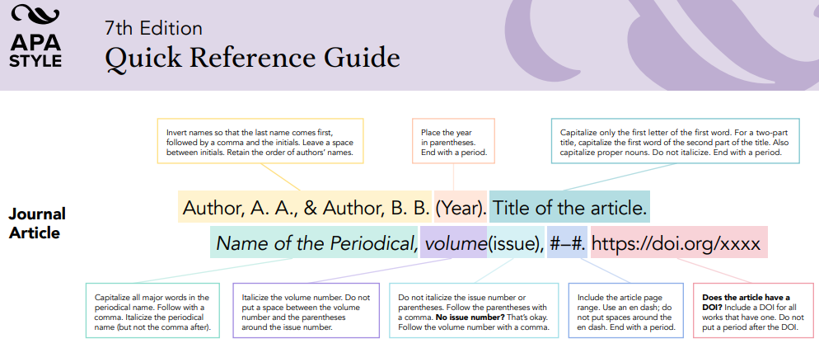

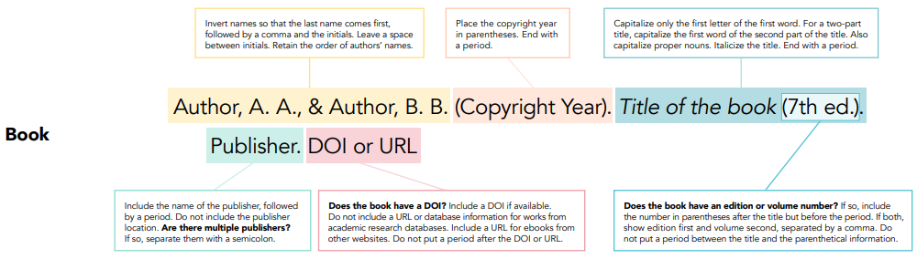

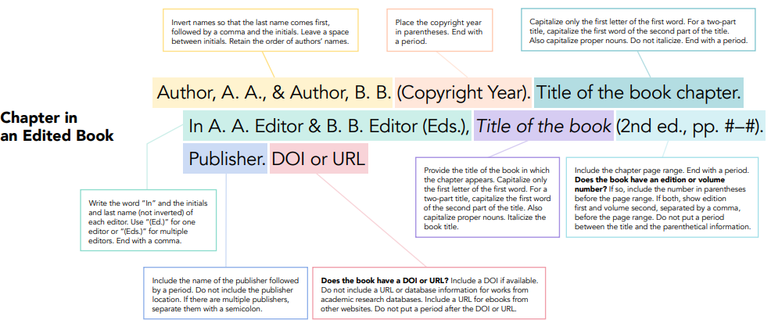

APPENDICES

Put additional information here that was gathered during your research but that you will not include in your paper i.e. Sample calculations, Research instruments, questionnaire or surveys sample, approval letter for data collection etc. Appendices may be in the form of figures, tables, maps, charts, photographs or drawing. The heading should be “Appendix” followed by a letter or number (e.g. “Appendix A” or “Appendix 1), centered and written in bold type.

AUTHORS PROFILE (All author profiles are mandatory)

Indicate the level of contribution of each author. All authors should include biographies with photo at the end of regular papers. Personal profile which contains details about their email id, education, publications, research work, membership, and achievements with photo and will be maximum 100-150 words.

Authoor-1 earned his B. Tech., M. Tech., and Ph.D. in physical science from IIT Bombay in 1998, 2002, and 2008, respectively. He is currently working as Professor in Department of Physical Science from IITRS, Bombay since 2010. He is a member of ISROSET since 2013, Life member of ACM since 2011 and a life member of the IIT Research Spectrum since 2015. He has published more than 50 research papers in reputed international journals including Thomson Reuters (SCI & Web of Science) and conferences including IEEE and it’s also available online. His main research work focuses on Cryptography Algorithms, Network Security, Cloud Security and Privacy, Big Data Analytics, Data Mining, IoT and Computational Intelligence based education. He has 15 years of teaching experience and 10 years of research experience.

Author’s formal photo
Authoor-2 earned his B. Tech., M. Tech., and Ph.D. in physical science from IIT Bombay in 1998, 2002, and 2008, respectively. He is currently working as Professor in Department of Physical Science from IITRS, Bombay since 2010. He is a member of ISROSET since 2013, Life member of ACM since 2011 and a life member of the IIT Research Spectrum since 2015. He has published more than 50 research papers in reputed international journals including Thomson Reuters (SCI & Web of Science) and conferences including IEEE and it’s also available online. His main research work focuses on Data Mining. He has 15 years of teaching experience and 10 years of research experience.

Author’s formal photo

